`



Yun Yue Du

|  |
| --- |
| CONTENT |

* **1 | Introduction………………………………....2**

**Getting Started with Yun Yue Du: A User’s Guide**

* + 1.1 | Background……………………………….........2
  + 1.2 | Process Overview......................................2
  + 1.3 | Security Information................................3
* **02 | Step-By-Step……………………………...…5**
  + 2.1 | Instruction on PC......................................5
  + 2.2 | Instruction on Wechat...........................10
  + 2.3 | Delivery and Return................................13
* **03 | Conclusion……………………………….….16**



# **1 Introduction**

**1 Introduction**

## **1.1 Background**

The "Yun Yue Du" platform of Southeast University is a new book express service launched by the library for readers, mainly offering Chinese books published after 2017. This platform provides a one-stop service for ordering and borrowing, allowing faculty and students to recommend new books online for purchase, with direct delivery via express mail, significantly reducing the time for readers to borrow new Chinese books.

The "Yun Yue Du" platform is mainly aimed at formal registered readers of the Southeast University Library, including faculty and students. Use your campus card number as the username and the last six digits of your ID card as the password. After logging in and binding your personal mobile phone number, you can activate and use the "Yun Yue Du" service.



## **1.2 Process Overview**

You can register and place orders through two methods: WeChat and PC:

**(1) WeChat:**

Click on "Yun Yue Du" in the "Services" menu at the bottom of the Southeast University Library's WeChat public account to register. The username is the campus card number of registered readers at Southeast University, and the password is the unified identity authentication password.

**(2) PC:**

Visit the "Readers' Book Recommendation" section on the middle right side of the library's homepage, click "Login" in the upper right corner, and log in with your student campus card number and unified identity authentication password. You need to bind your mobile phone number upon first login. After binding, you can borrow and purchase in the "Yun Yue Du" section.

**1 Introduction**

After registration, users must fill in the correct mailing address and contact information, and confirm receipt in the "My Yun Yue Du" section of the personal center after the express delivery arrives.

## **1.3 Security Information**

(1) Danger：

① Malicious access to unauthorized third-party accounts.

* Consequence: It may lead to personal information leakage, account theft, and even legal responsibility.
* Avoidance: Ensure you log in with your personal campus card number and the last six digits of your ID card as the password, and change your password regularly.

(2) Warning：

① Incorrect or incomplete delivery address.

* Consequence: It may result in the books not being accurately delivered, delaying the borrowing experience.
* Avoidance: Carefully check and accurately fill in the delivery address when placing an order. Update the delivery address in the personal center promptly if there are any changes.

② Overdue return of books.

* Consequence: It may lead to the suspension of borrowing privileges and affect personal credit records.
* Avoidance: Pay attention to the borrowing period and return the books before the due date. If you are unable to return on time, contact customer service to explain the situation。

(3) Caution：

① Books may be damaged during transportation.

* Consequence: It affects the Yue Du experience and may require compensation.
* Avoidance: Carefully inspect the condition of the books when confirming receipt. If you find any damage or water damage, contact customer service through "QQ Consultation" immediately.

**1 Introduction**

② Incorrect operation at the self-service borrowing and returning machine, resulting in books not being properly returned.

* Consequence: It may lead to overdue books and affect personal credit records.
* Avoidance: Do not use the self-service borrowing and returning machine to return "Yun Yue Du" books. Be sure to go to the library's circulation service desk and leave only after the staff have confirmed the effective return.

③ Books not found on the "Yun Yue Du" platform.

* Consequence: Readers may not be able to borrow required books immediately.
* Avoidance: Since "Yun Yue Du" only offers new Chinese books published after 2017, for other books, readers can go to the "Yun Yue Du" homepage—Latest Books—Self-recommendation to submit book recommendations.



# **2. STEP-BY-STEP**

**2.1 Instruction on PC**

## **2.1 Instruction on PC**

**Step 1: Access the Platform**

Open your web browser and navigate to the website address:

[www.yuntaigo.com/seu.html.](http://www.yuntaigo.com/seu.html." \l "tdsub" \t "dlf)

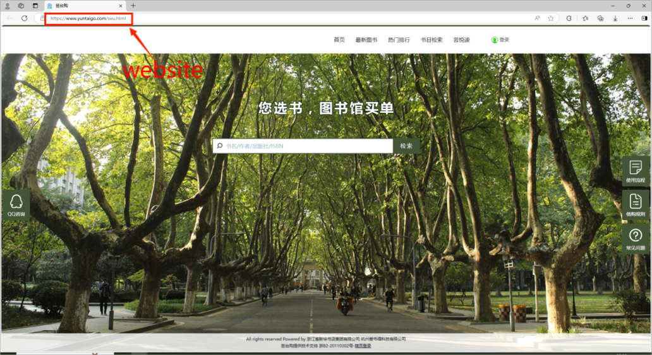

**Step 2: Login to the Platform**

Locate and click on the "Log on" button located at the top right corner of the homepage.

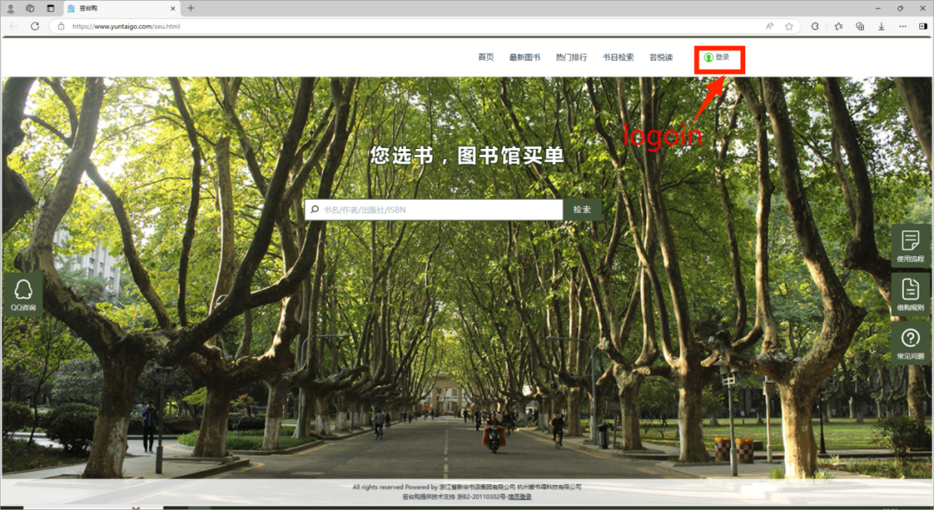

**Step 3: Identity Authentication**

**2.1 Instruction on PC**

Enter your one-card number as the account and the last 6 digits of your ID number as the password for identity authentication.

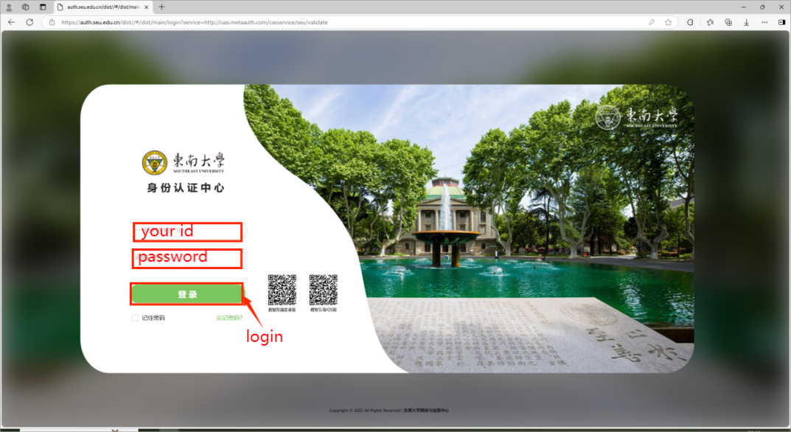

**Step 4: Bind Your Mobile Phone**

After successful identity authentication, proceed to the mobile binding page.

Enter your mobile number and complete the binding process.

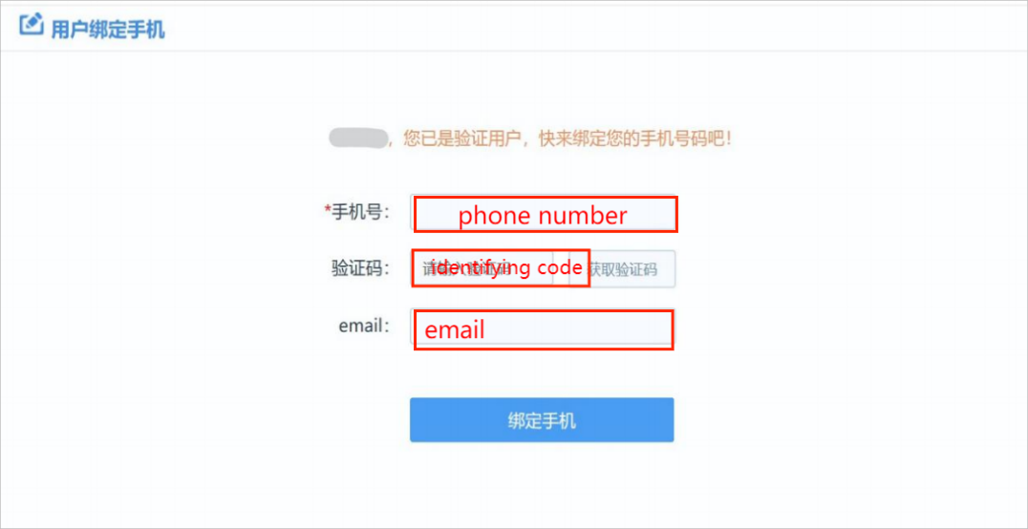

**Step 5: Select Books and Place an Order**

Navigate to the "Yun Yue Du" module.

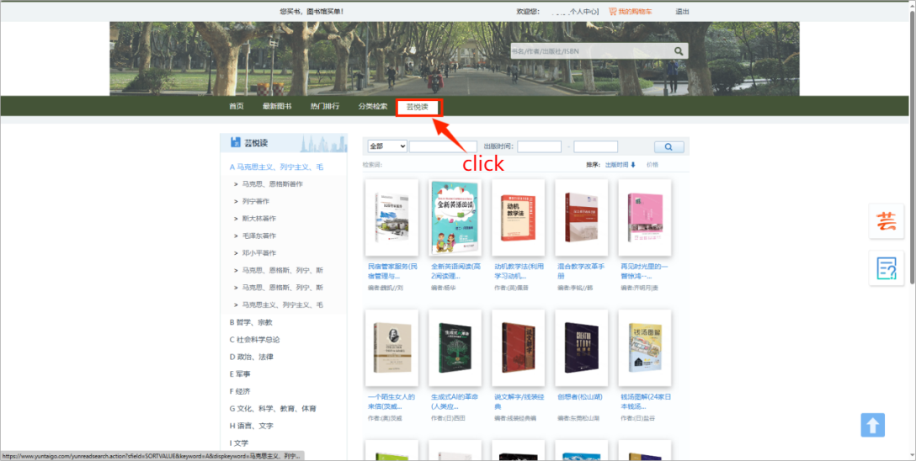

**Step 6: Select books for free**

**2.1 Instruction on PC**

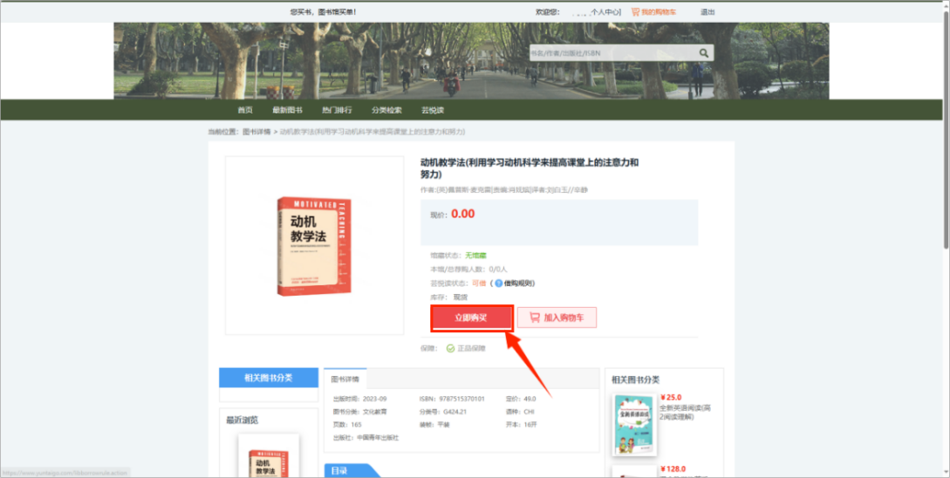

**Step 7: Provide or Update Shipping Address**

Fill in or create a new shipping address where you want the book to be delivered.

Confirm the address details to ensure accurate delivery.

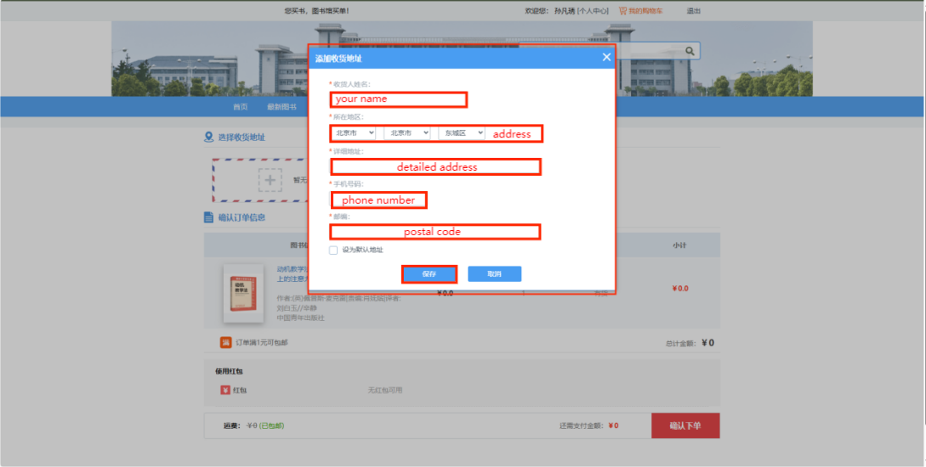

**2.1 Instruction on PC**

**Step 8: Confirm Your Order**

Review your order details, including the book selection and shipping address.

Click "Confirm the order." to complete the borrowing process.

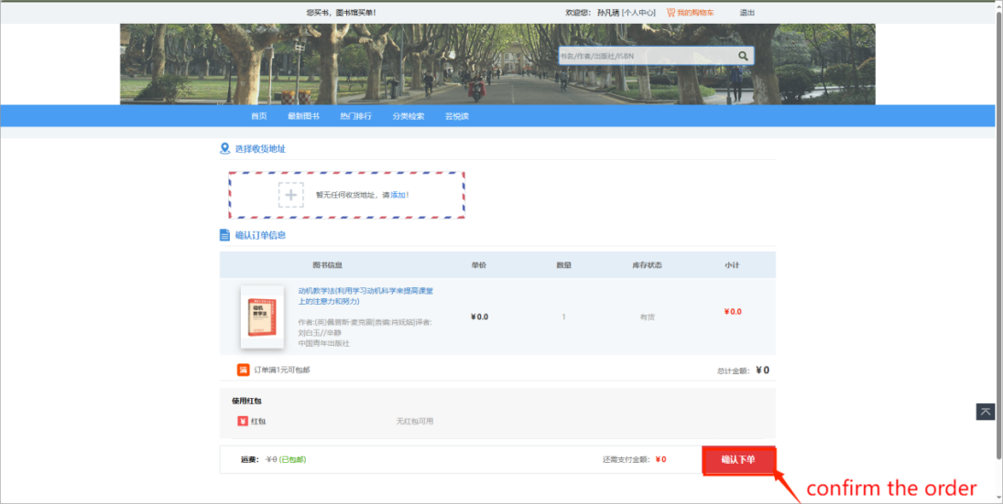

**Step 9: Confirm Receipt of Books**

Once the book is delivered, log in to your personal center, navigate to "My Yun Yue Du" and then "My borrowed purchase" to confirm receipt.

If not confirmed within 10 days, the system will automatically confirm receipt.

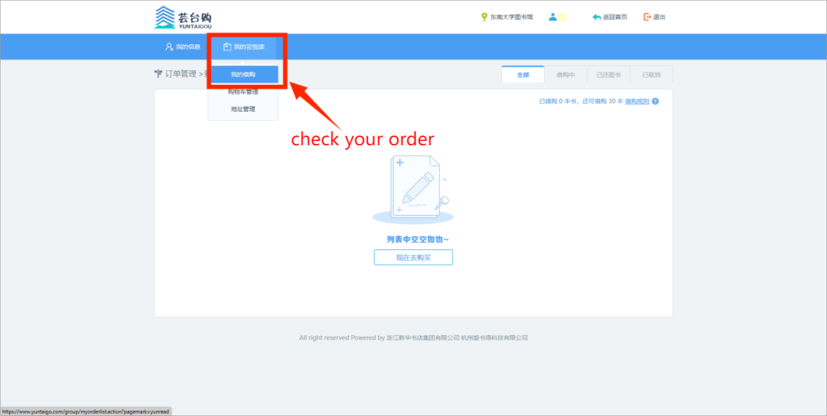

**2.1 Instruction on PC**

**Step 10: Contact Support if Necessary**

If you encounter any issues with the order, such as logistics problems or damaged books, contact "QQ Consultation" for assistance.

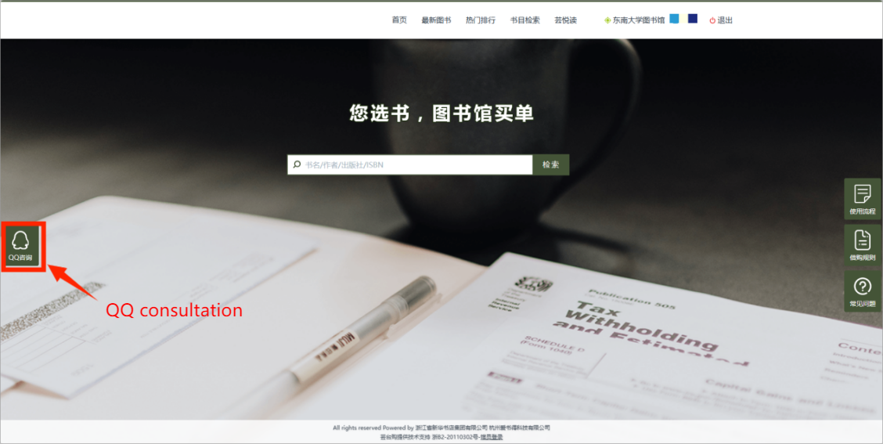

**Step 11: Return the Book**

Return the book in good condition to the circulation service desk of any Southeast University library before the borrowing period ends.

**2.2 INSTRUCTION ON WECHAT**

**2.2 Instruction on Wechat**

**Step 1: Scan to Follow**

Search and follow the "Southeast University Library" official WeChat account.

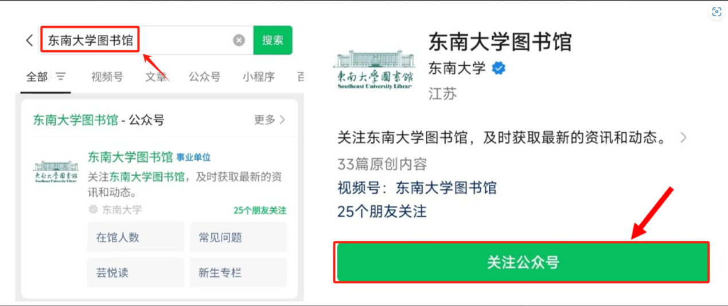

**Step 2: Register and Activate**

* Click on the "Services" module in the Southeast University Library menu and select "Yun Yue Du".

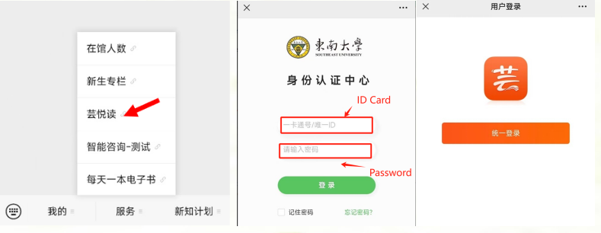

* Perform identity verification on the login interface (account is the one card number, password is the last 6 digits of the ID number).
* First-time login requires binding your personal mobile phone number.

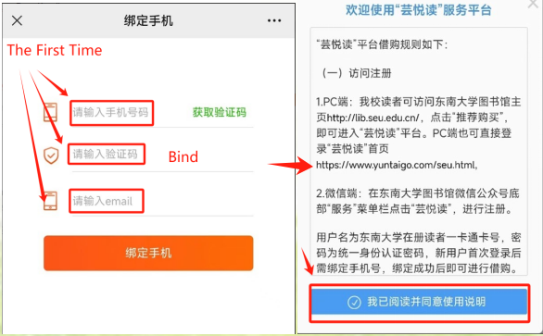

**2.2 Instruction on Wechat**

* After completing the phone binding, you can enter the “YunYueDu” module to borrow and purchase books.

**Step 3: Select Books and Place Orders**

* Place an order for borrowing and purchasing.

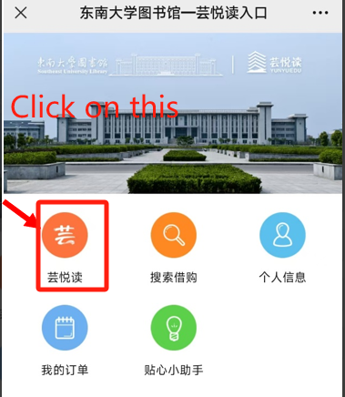 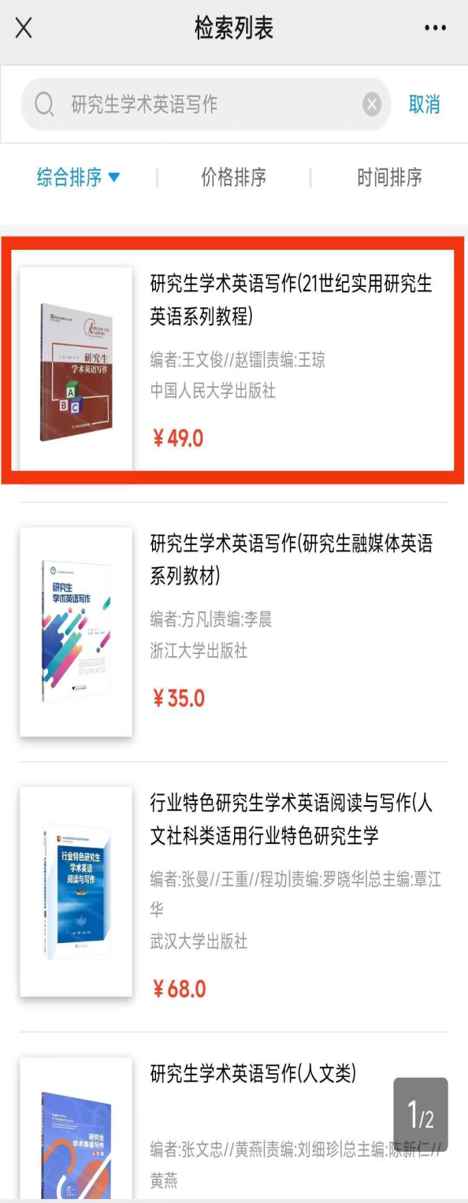

* Choose or create a new delivery address and submit the order.
* Complete the borrowing and purchasing process.

**Step 4: Confirm Receipt**

Once the delivery arrives, confirm receipt in the WeChat interface under "My Orders" -> "My Borrowing and Purchasing." (The system will automatically confirm receipt within 10 days after shipment.)

**Step 5: Confirm Receipt**

**2.2 Instruction on Wechat**

* Before the end of the borrowing period, readers must return books to the circulation service desk of any Southeast University campus library. Readers must ensure the return is confirmed by staff before leaving; Readers cannot return books via self-service machines.
* During the borrowing process, if books are damaged, stained (annotations, markings, circles, etc.), or lost, readers are responsible for compensation. For specific rules, refer to Southeast University's "Library Violation Handling Regulations."
* If readers return books late, they cannot borrow or purchase new books.

**2.3 Delivery and Return**

**Step1:**

**2.3 Delivery and Return**

After the order is reviewed by the administrator, click on the person's name in the upper right corner to enter the personal center, and you can track the logistics of the book package in My YunYueDu - My Borrowing and Purchasing.

**Web version:**

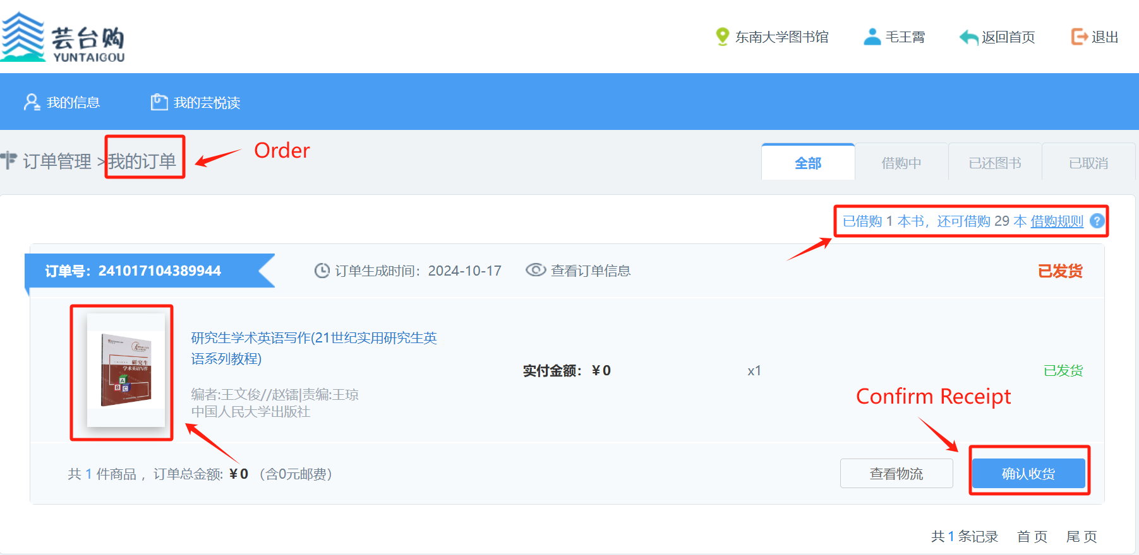

**Wechat version:**

**Step2:**

If the logistics information shows that the package has arrived, please pick it up in a timely manner to avoid the package being returned and causing unnecessary disputes

Here is specific information about several major courier centers on campus.

**Orange Garden Rookie Station:**

Business hours: Monday to Sunday, 8:00am to 7:00pm

**Meiyuan Cainiao Station：**

Business hours: Monday to Sunday, 8:00am to 7:00pm

**2.3 Delivery and Return**

**Post Office：**

Postal services: Monday to Saturday 9:30-16:30

Shipping service: Monday to Sunday 9:30-21:30

The followings are the three express stations mentioned.

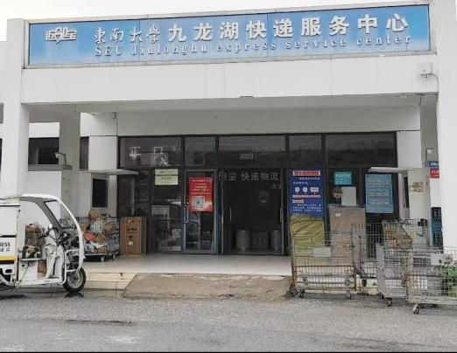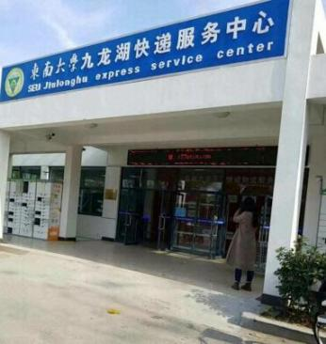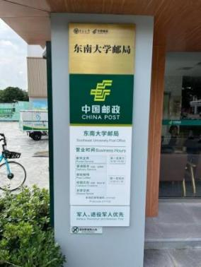

Step3:After arrival, check if the outer packaging of the express delivery is damaged

**Step4:**

Open the package and check if the books are in good condition

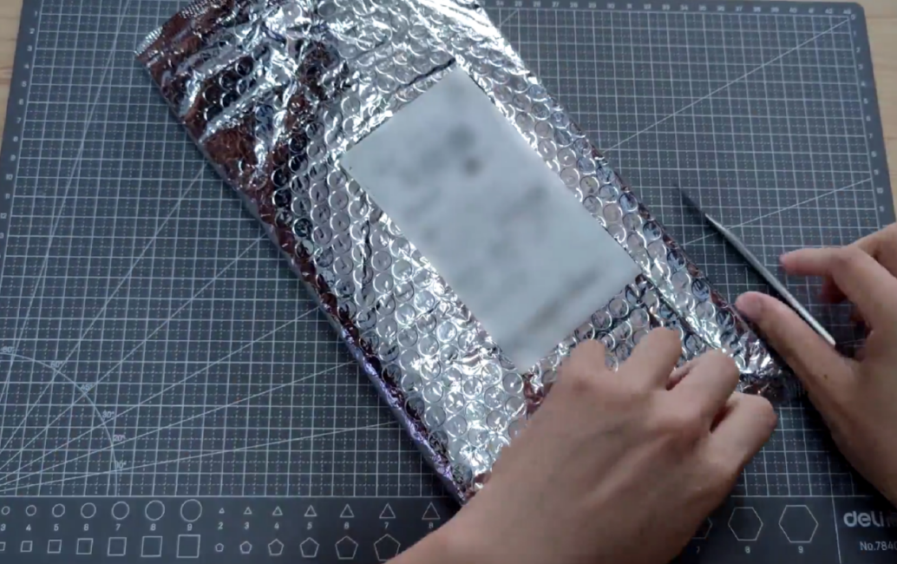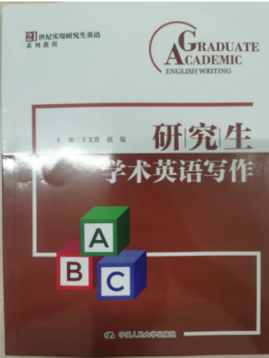

**Step5:**

If there are no issues, the reader can confirm receipt in the personal center → My Yun Yue Du → My Borrowing Purchase.(as step 1 introduced)

**2.3 Delivery and Return**

**Step 6:**

If readers encounter logistics issues during the period from order confirmation to receipt confirmation, they can contact the "QQ Consultation" on the Yun Yue Du homepage.

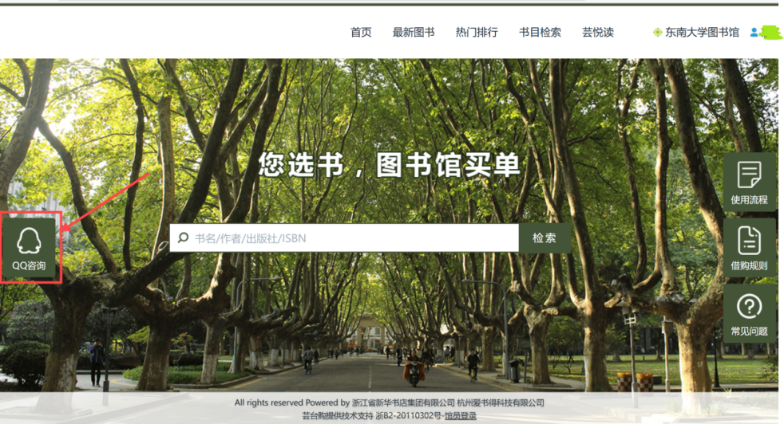

# **3 Conclusion**

**3 Conclusion**

By completing five simple steps—logging into the platform, registering and activating your account, selecting and placing an order, confirming receipt, and returning the books—Southeast University Library offers readers a one-stop service for ordering and borrowing books.

With the **Yun Yue Du** platform, "You choose the book, we pay the bill." It provides access to a vast collection of physical books, combining the strengths of bookstores and the library. Under the "Internet+" model, it introduces a new way of borrowing books, offering a convenient borrowing experience from the comfort of your home. You can stay up-to-date with all the latest arrivals at the bookstore, place an order with just a few clicks, and once the order is successful, the bookstore will immediately ship the book to your doorstep, with the library covering the cost.

**Q&A:**

**Is the book return process for Yun Yue Du the same as for books borrowed from the library?**

● The return process for Yun Yue Du books differs from that of regular library books. Yun Yue Du books cannot be returned via the self-service machines; instead, they must be returned to the circulation desk of any Southeast University library branch, and readers should confirm the return with staff before leaving.

**What do the different messages on the order page mean?**

● *Available for Borrowing*: You can place an order for this book.

*● Library Copies Full: The library has already acquired two copies of this book, and no more can be borrowed.*

*● Borrowing Limit Reached: You have reached the personal borrowing limit of two books. Please return a book to borrow another.*

*● Service Not Activated: Please check if you have overdue Yun Yue Du books. If so, return them to restore service; if not, contact fyy@seu.ed*u.cn to check your account.

● *Insufficient Stock*: The book is out of stock. You can place an order once it's restocked.

**Why are the "Add to Cart" and "Borrow" buttons grayed out?**

● This might occur if the book's status shows "Library Copies Full," meaning the library has already acquired two copies or two readers have already borrowed it. Yun Yue Du allows only two copies to be borrowed at a time. Check if the library still has a copy available, or wait for the book to be returned and restocked.

**3 Conclusion**

**Why can’t I find the book I want on the platform?**

● Yun Yue Du is a new book delivery platform, providing only Chinese books published after 2017. For other book recommendations, visit the Yun Yue Du homepage under "New Books" and submit the relevant information to recommend a title.

**Do I need to pay for shipping when borrowing books?**

● No, the library covers the shipping cost for Yun Yue Du books, so you don’t need to pay any fees. However, make sure to pick up the package promptly after receiving a delivery notification to avoid any returns or disputes.

**Do I have to order at least two books each time?**

● While you can borrow up to two books at once (e.g., a multi-volume set counts as one book), you are not required to borrow two books in a single order. Once you return a borrowed book, your borrowing quota will be updated, allowing you to borrow another book, as long as the total number of Yun Yue Du books in your possession does not exceed two.

**Can I track the delivery status of my books after placing an order?**

● After your order is approved by the administrator, you can track the delivery in your personal account under “My Yun Yue Du” → “My Orders.” Once the book is delivered, confirm receipt through the same section.

**How long can I borrow a book from Yun Yue Du?**

● The borrowing period is 30 days, with extensions available for holidays. Please return books on time to avoid affecting future borrowing or graduation clearance. If you have issues with the borrowing period, contact fyy@seu.edu.cn.

**Who should I contact if I encounter issues while using Yun Yue Du?**

● For any logistics issues during the order process, use the "QQ consultation" option on the Yun Yue Du homepage. If there are questions about rejected orders, email fyy@seu.edu.cn.